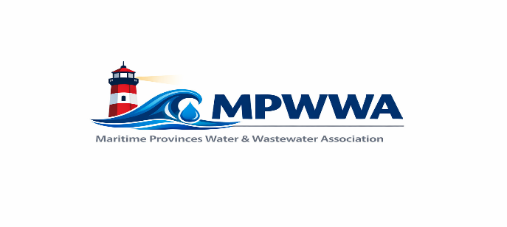

MPWWA Operational Excellence Award Nomination Form

Nomination Contact Information
Nominee Name: _________________________________________________________________

Award Category Nominated For: Water Treatment/Distribution

Wastewater Collection/Treatment

Nominee’s Work Location/Facility: __________________________________________________

Nominated By:

Name: __________________________________________________________________________

Connection to Nominee: ___________________________________________________________

Mailing Address: _________________________________________________________________

City, Province: ______________________, ________________ Postal Code: ________________

Phone: ____________________________ Email: _____________________________________

The MPWWA ‘Operational Excellence Award’ recognizes an individual operator who through their work, provides excellent service delivery. Please complete the form with as detailed information as possible for review by the award selection committee. You will be notified if your nomination is successful and the award will be presented at the MPWWA Annual Training Seminar.

“Good Luck to your Nominee”

Selection Criteria
(detailed nomination information in the guide for Operational Excellence Award program)

Operational Oversight Details:

Training and/or Mentoring Details:

Decision-Making Details:

Civic Involvement Details:

Due Date: April 1, 2027
Selection: Selection will be based on the nomination details provided, the principle of open and equal opportunity, and carried out by a committee of the Board of Directors. Their decision will be final. The award winners will be presented at the Annual Training Seminar.
Thank you for your submission and good luck to your nominee!

