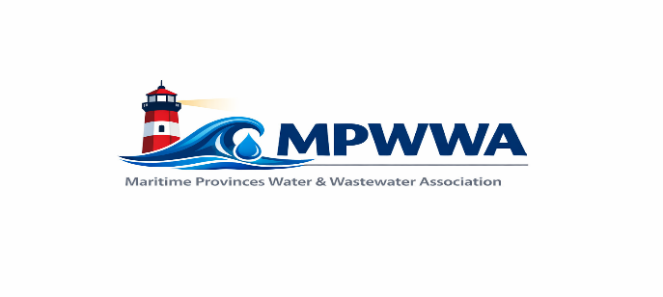
Call for Presentations

44th Annual Training Seminar
Summerside, PEI
April 11-14, 2027

The Maritime Provinces Water & Wastewater Association will be accepting submissions for workshop presentations for the MPWWA Annual Training Seminar in Summerside, PEI.

Effective and relevant training helps us continue to protect public health and the environment in the communities we serve. The theme for our 44th Annual Training Seminar is:
“Managing Your System Today, Preparing For The Future”.

MPWWA will be accepting abstract submissions for all topics related to water and wastewater that meet with the theme. Presentations shall be 1 hour in length - approximately 45 minutes for the core presentation with 15 minutes to accommodate questions from the delegates.

Have you been involved in a project? Maybe you have an innovative idea or product you would like to share with Maritime water and wastewater operators? Please provide a brief presentation outline for consideration to share with your peers.

Please have abstracts submitted by November 2, 2026. Any abstracts not used for this seminar may be held for future seminar consideration.

Abstracts may be submitted electronically in ‘Microsoft Word’ format for consideration with contact information to:

Clara Shea, MPWWA
contact@mpwwa.net

